IVY TECH COMMUNITY COLLEGE
SDEV 220 Python Programming
Chapter 12

YOUR NAME: _______Giovanna Gorski______________________________________

TO START YOUR PROGRAM
At the top of each of your Python programs, you should have four lines of documentation:
Program name (the Python file name), Author (your name), Date last updated, and Purpose (a brief description of what the program accomplishes). Here is an example:
# Program name: TemperatureConverter.py
# Author: Carl LaFong
# Date last updated: 5/16/2012
# Purpose: Print out your name, address, phone #, and college major

Leave a blank line and then begin to write your program

ASSIGNMENT: Programming Exercise #3 on page 524, and #7 on page 525.
- Programming Exercise #3 (Recursive Lines):
  - Name your Python program recursive_lines.py.
  - Your program should ask the user for the number of lines to be drawn. Ensure that the number entered is 1 or greater.
  - Hint: Review pages 65-66 to see how to print something without the newline character.
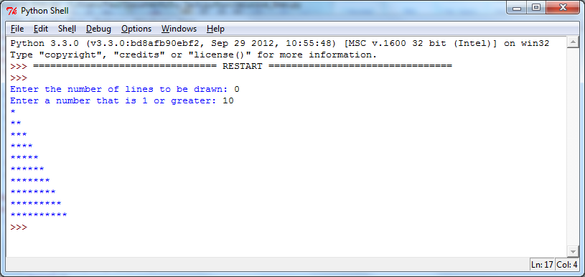
  - Above is an example of what the program interaction might look like. Yours does not have to look exactly like this, as long as it works correctly:
- Programming Exercise #7 (Recursive Power Method):
  - Name your file recursive_power.py.
  - Ask for the user to enter a base number, and an exponent (the power to raise the base to). Ensure that the exponent is a non-negative integer. This means 0 and 1 are valid exponents.
  - Above is an example of what your program interaction might look like. It does not have to be exactly like this, as long as it works correctly. This shows the program run three times, with the numbers 3333 and 0, 555 and 1, and 4 and 6.
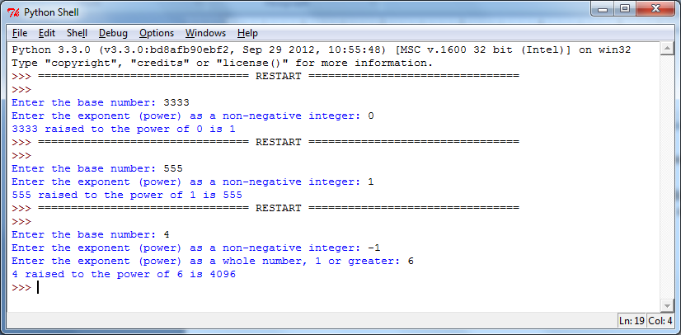
  - Be sure to include the four lines of documentation at the top of each program, and a short comment above every line or small section of Python code.

HOW TO SUBMIT YOUR ASSIGNMENT
Save and close your Python files. In Blackboard, go to the Class Session where this assignment is posted, attach your Python file(s), (Example: jcSalesPrediction.py) and submit for grading. For this assignment, you should submit two program files.

